Memo stat

lefnei shemathilim, kedai liftoah kovez ehad im texst editor ve pashut lhistakel al hakovez. Lrot beeize safa hou. Im ho mofrad be psik o be tab lemashal.

Ahar kah yesh kama sifryot she kedai lehacir.

import pandas as pd
from os import listdir
from matplotlib import rcParams
rcParams['figure.figsize'] = 15, 3

!pip install unidecode
import os
import zipfile
import pandas as pd
from unidecode import unidecode
import io

pd.read_csv(file_name, encoding='ISO-8859-1', sep='\t', index_col=False)

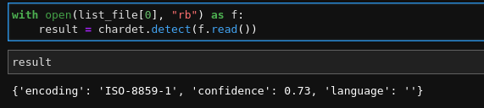
kaha efshar limzo eize sog mefaneah et hakovez.
Ha “sep” mahnis eize tab o medaleg al eize tab. Ve meafsher likro et hakovez.

